# Holzmaschine Technical Reference

## Overview

## Description

# Technic

## Overview

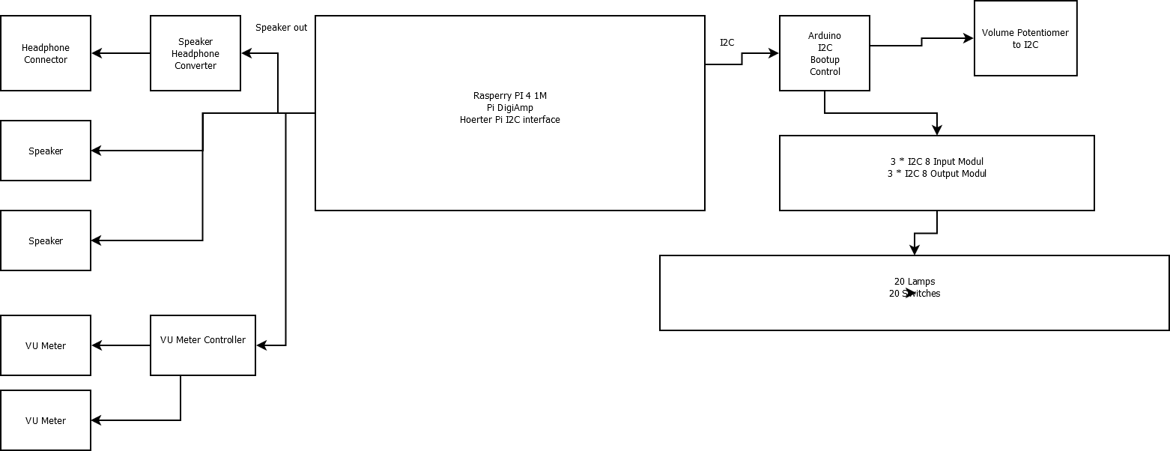

+ ana - +

5V

Pontentiometer

-

12 V

+

1

2